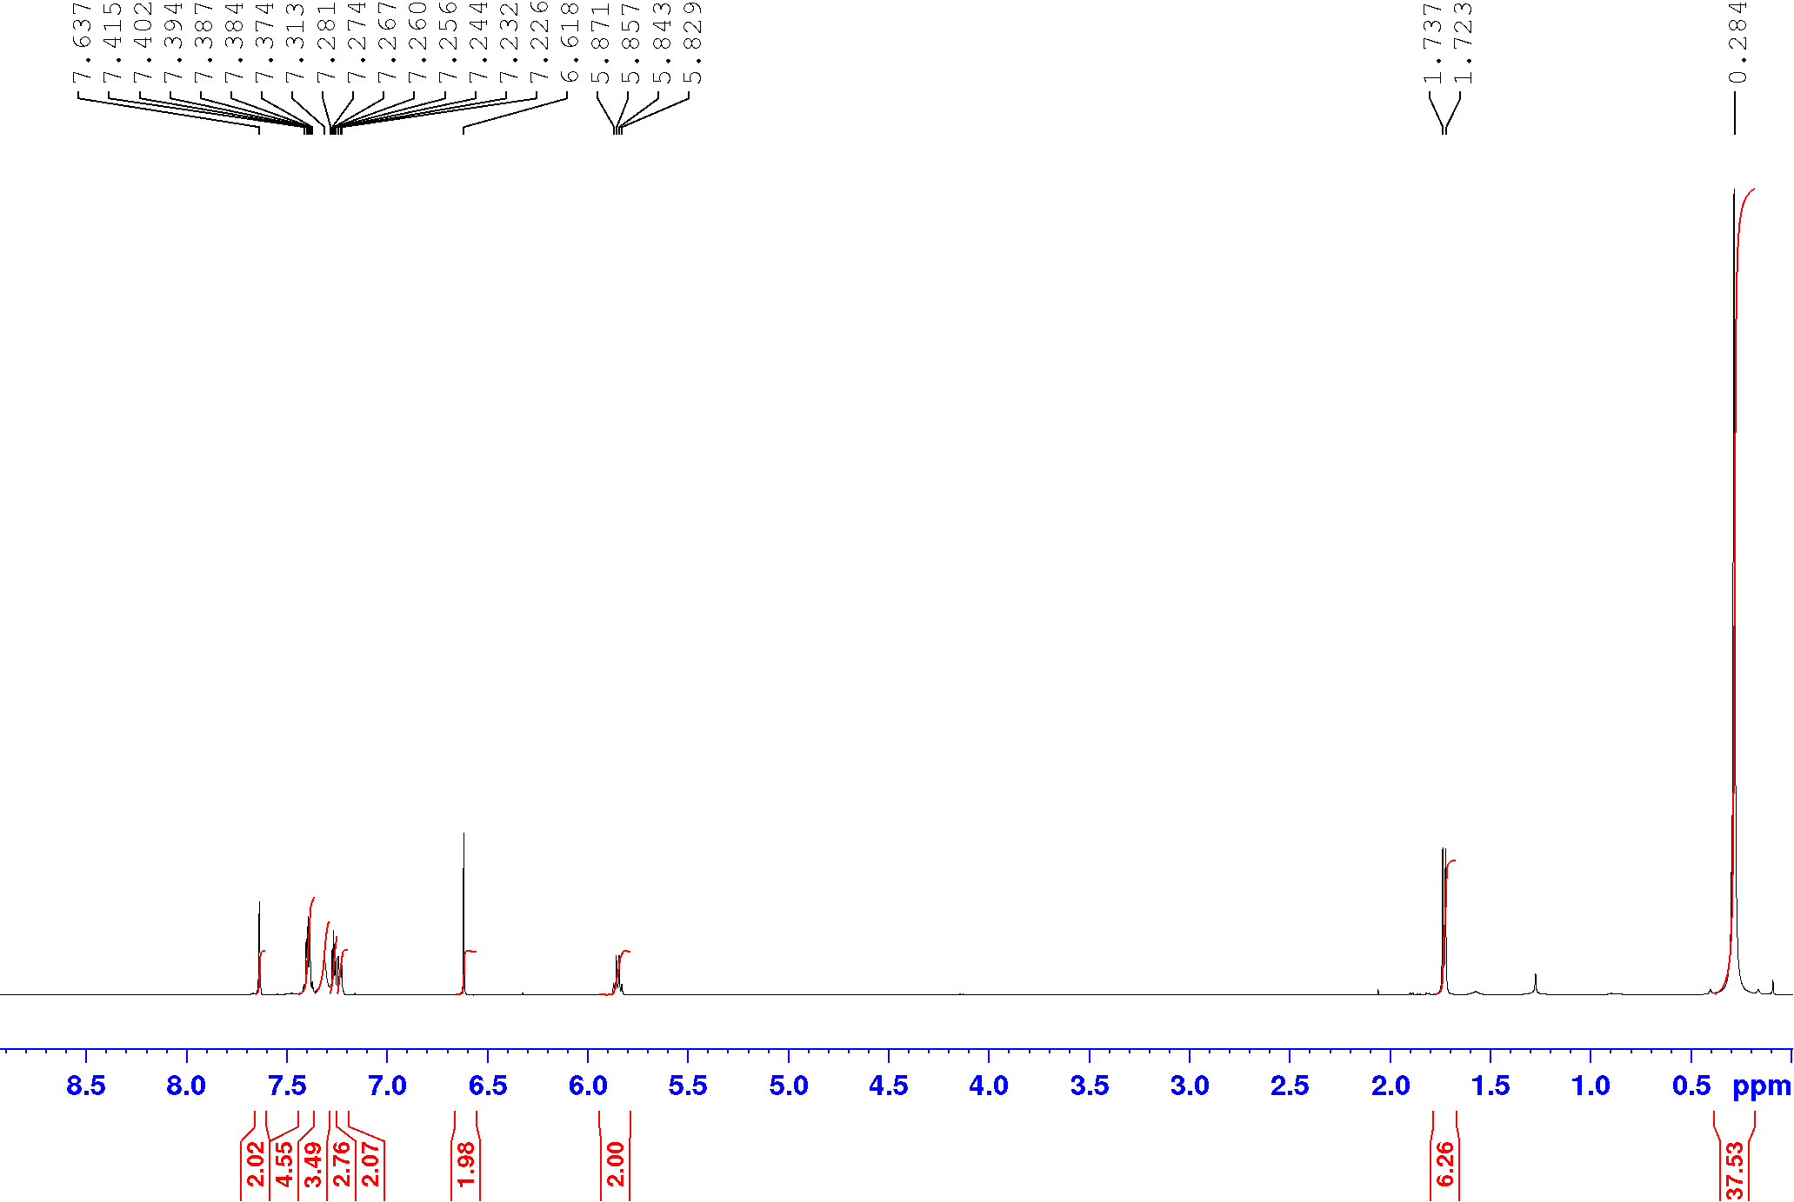



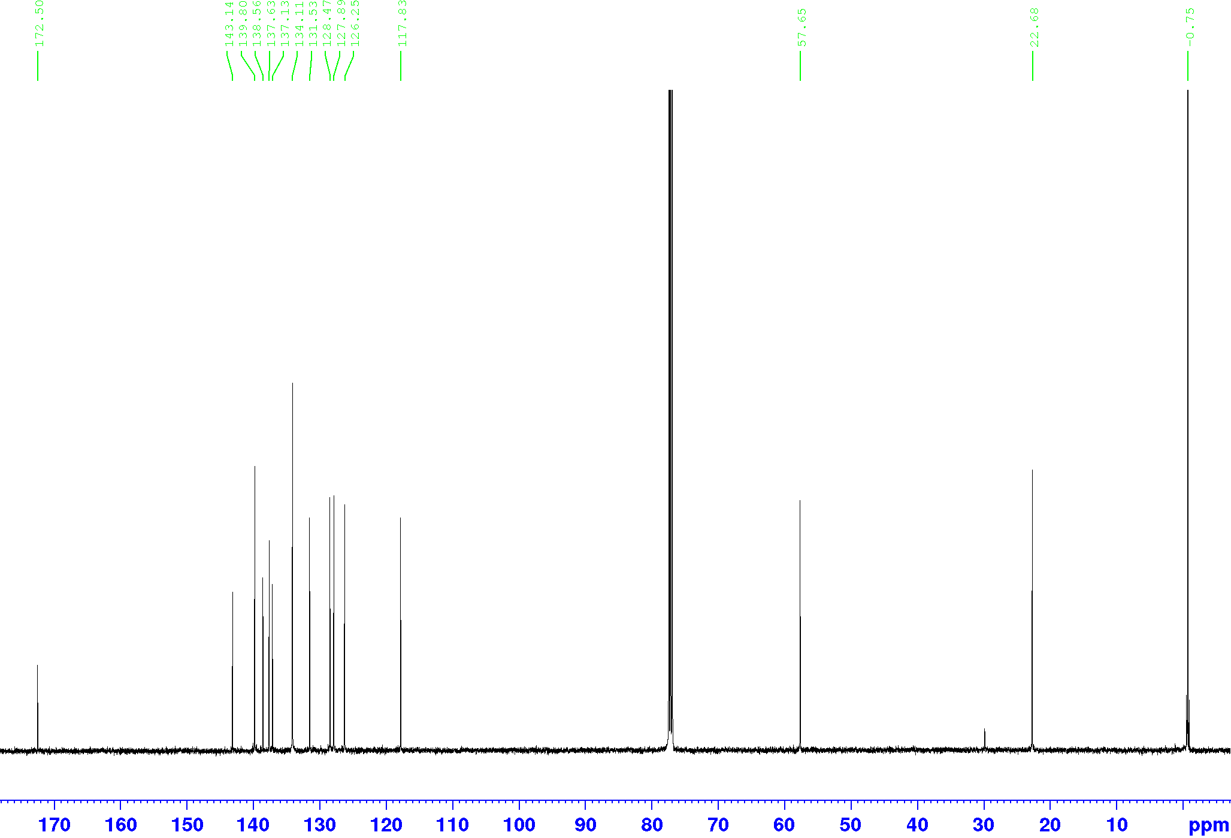



**Figure 1.** Top: 1H NMR of the gold complex **17a**; bottom: 13C NMR of the gold complex **17a.**

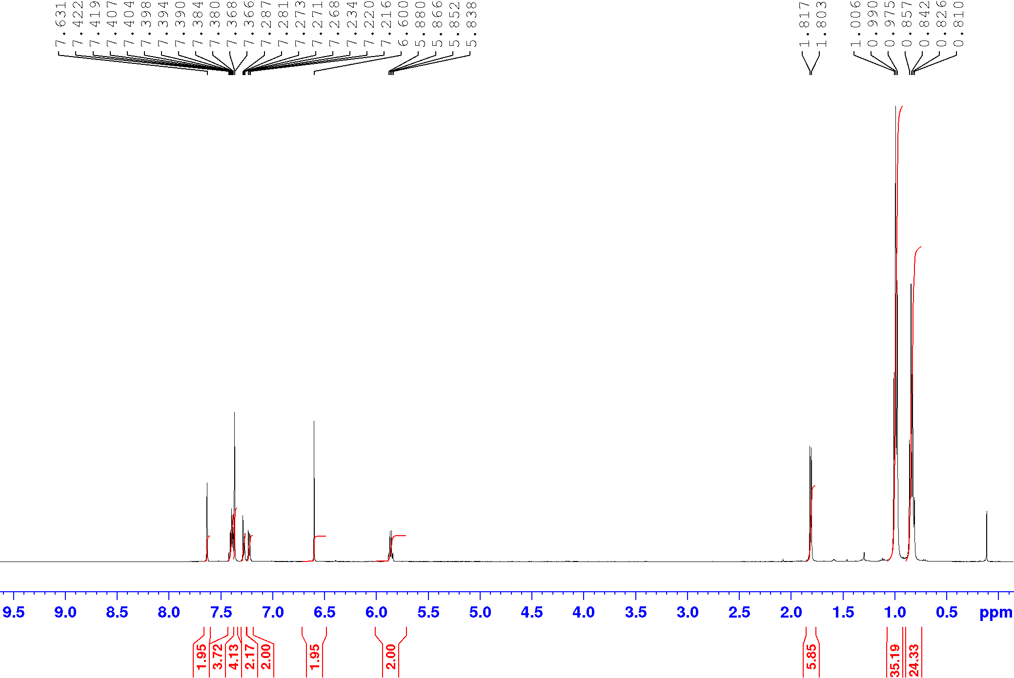



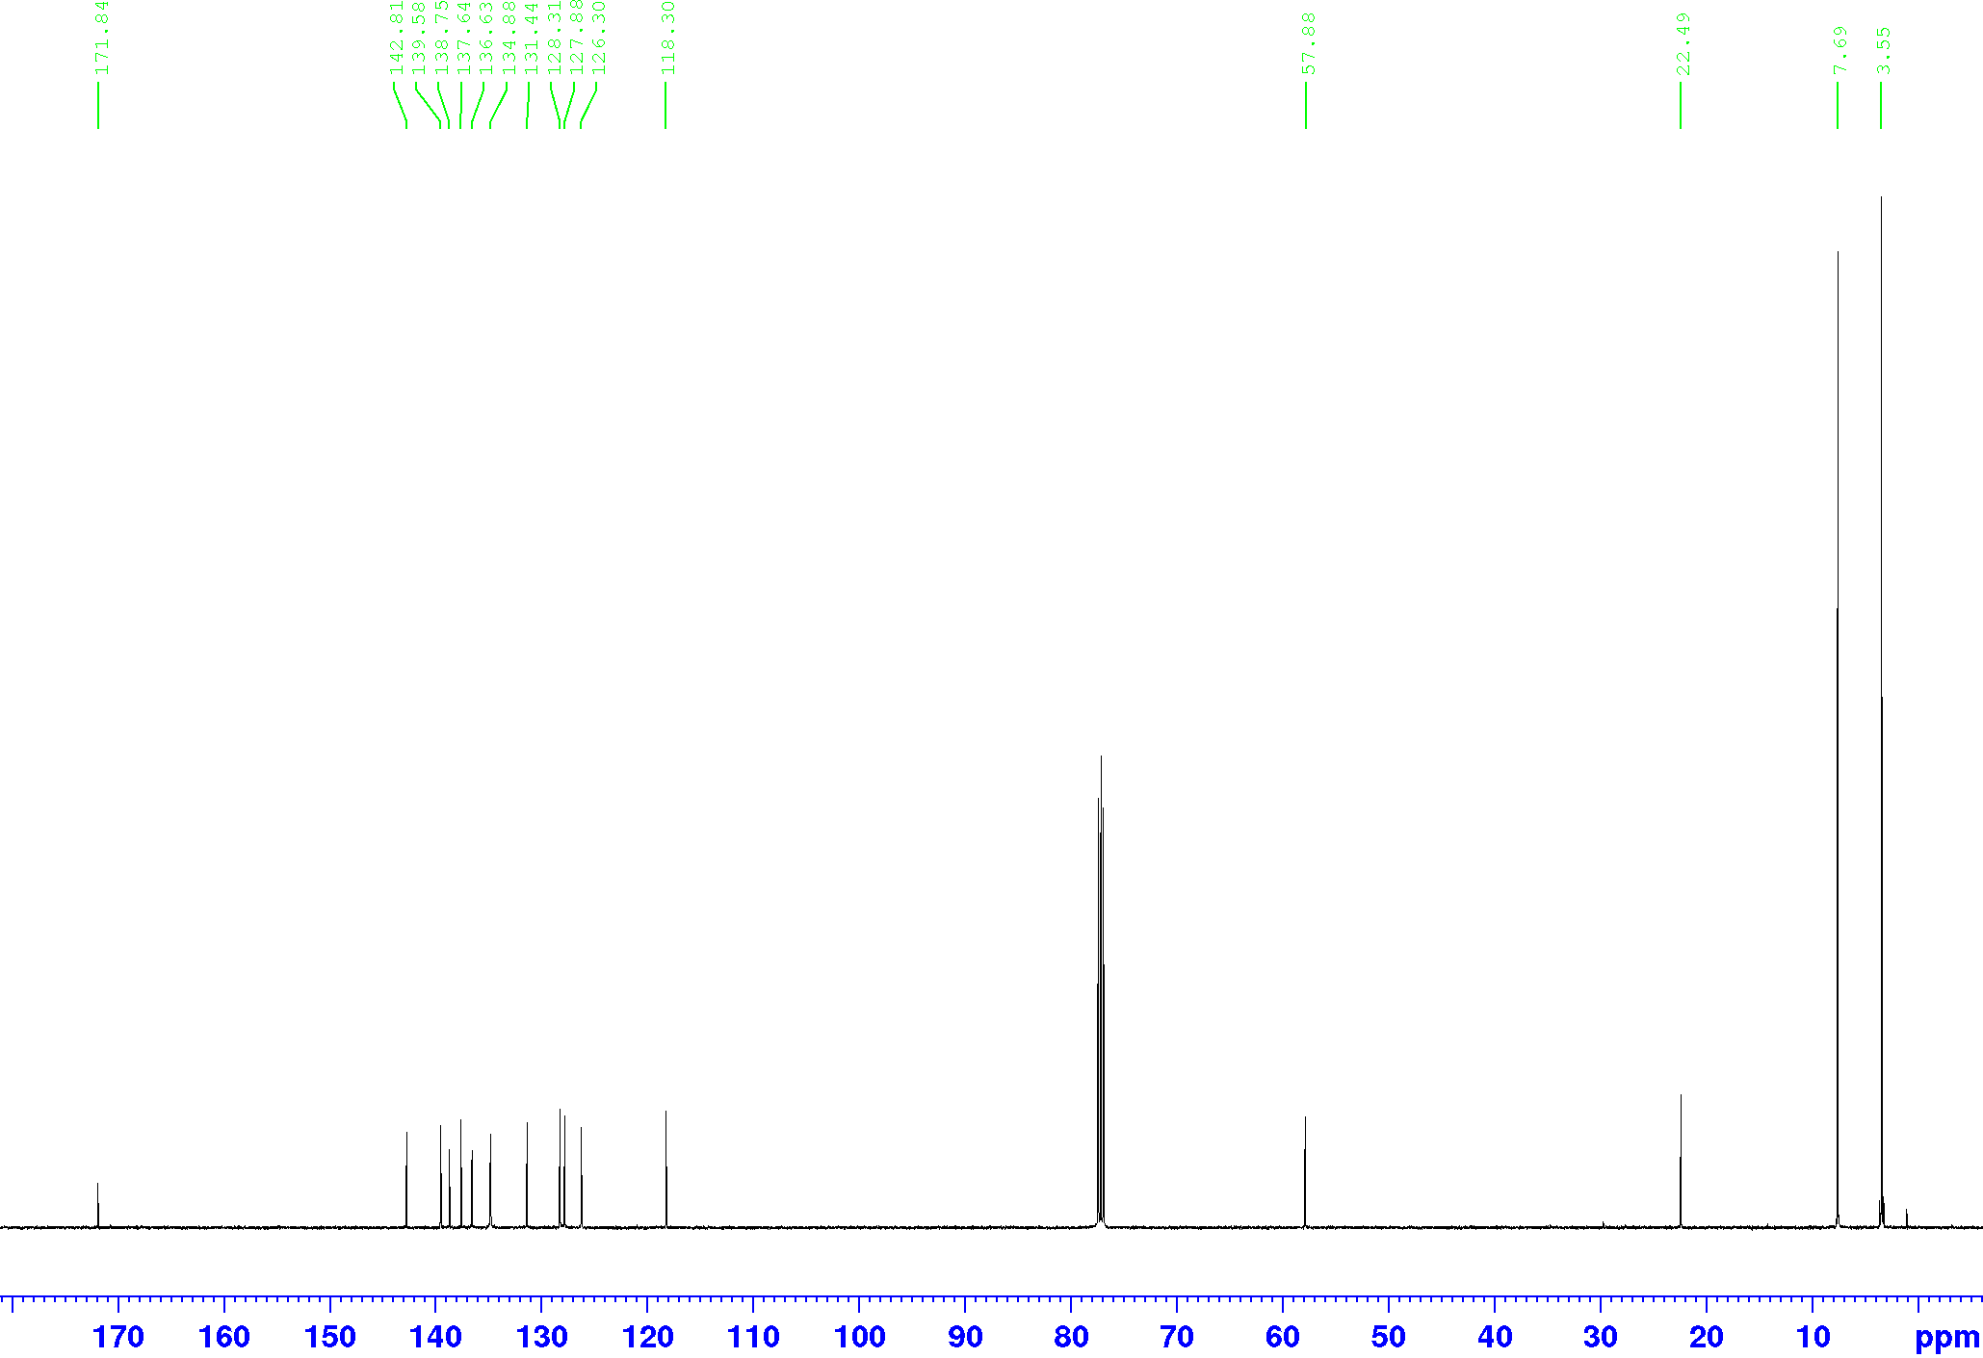



**Figure 2.** Top: 1H NMR of the gold complex **17b**; bottom: 13C NMR of the gold complex **17b.**

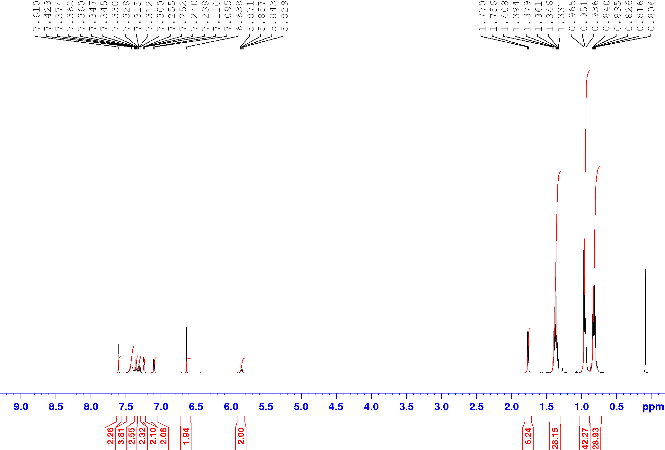



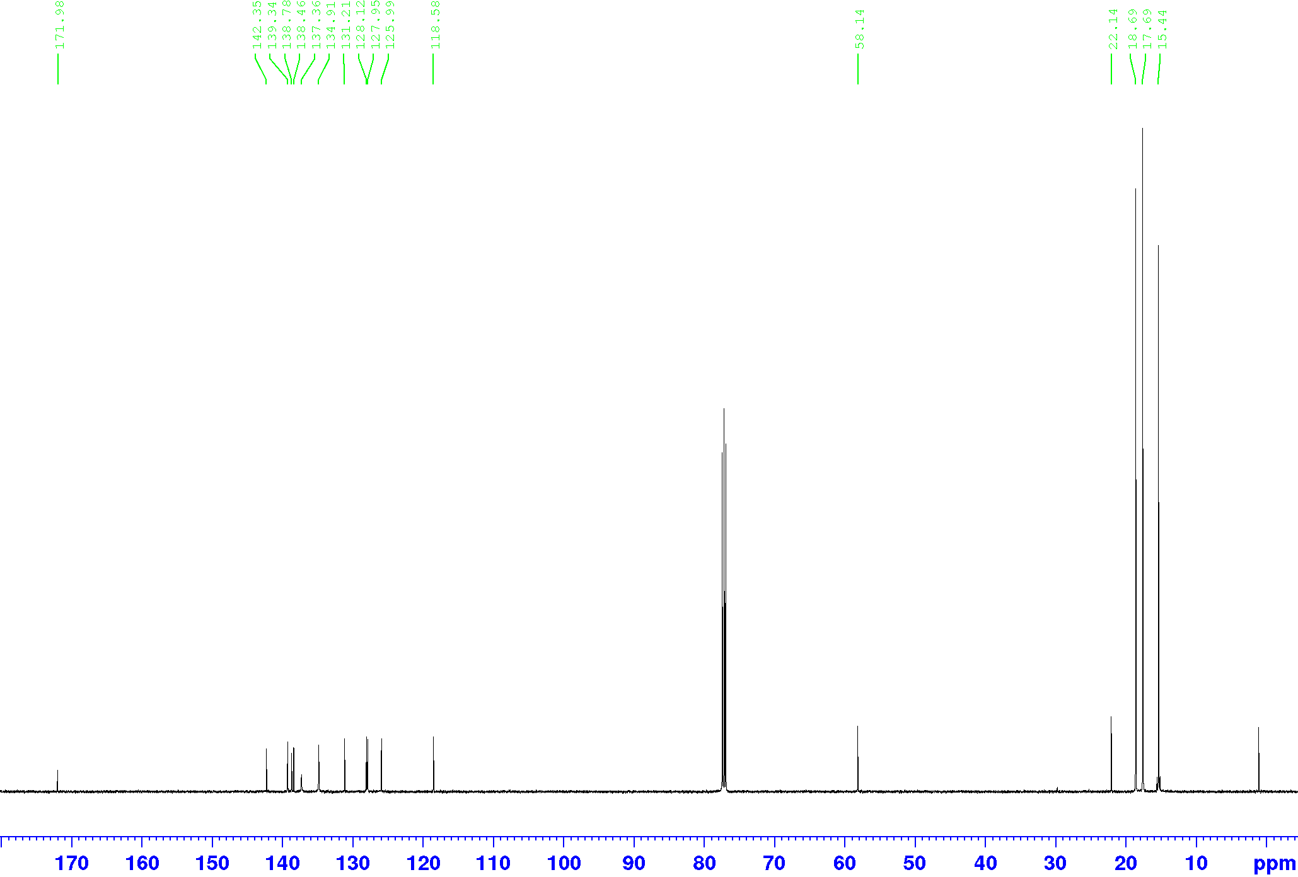



**Figure 3.** Top: 1H NMR of the gold complex **17c**; bottom: 13C NMR of the gold complex **17c.**

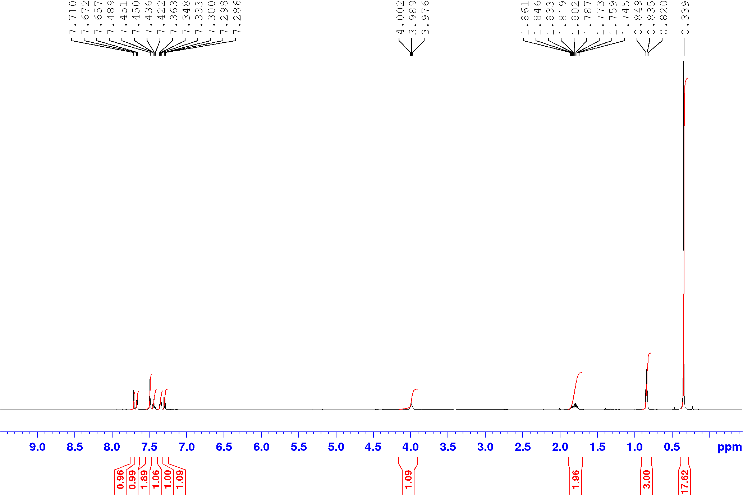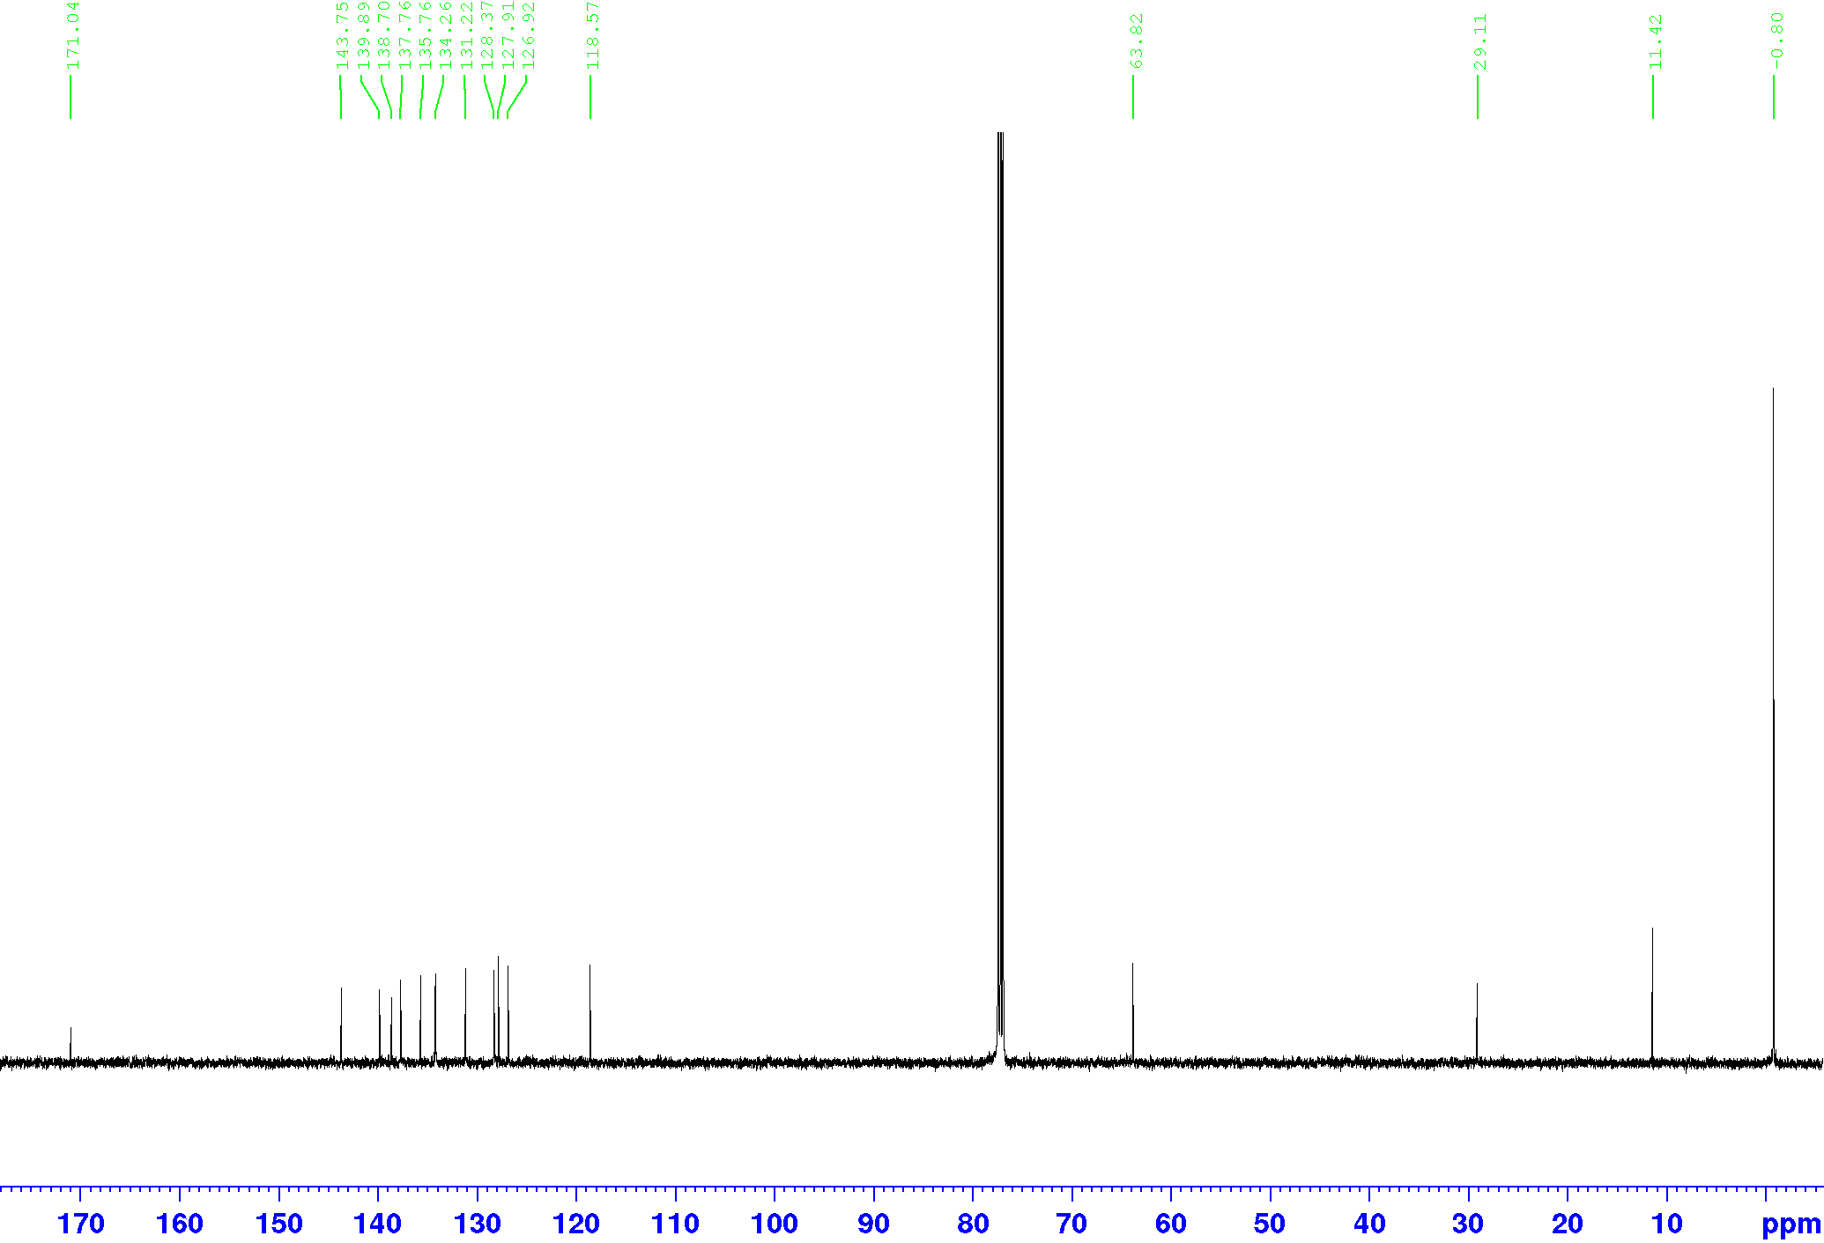



**Figure 4.** Top: 1H NMR of the gold complex **18a**; bottom: 13C NMR of the gold complex **18a.**

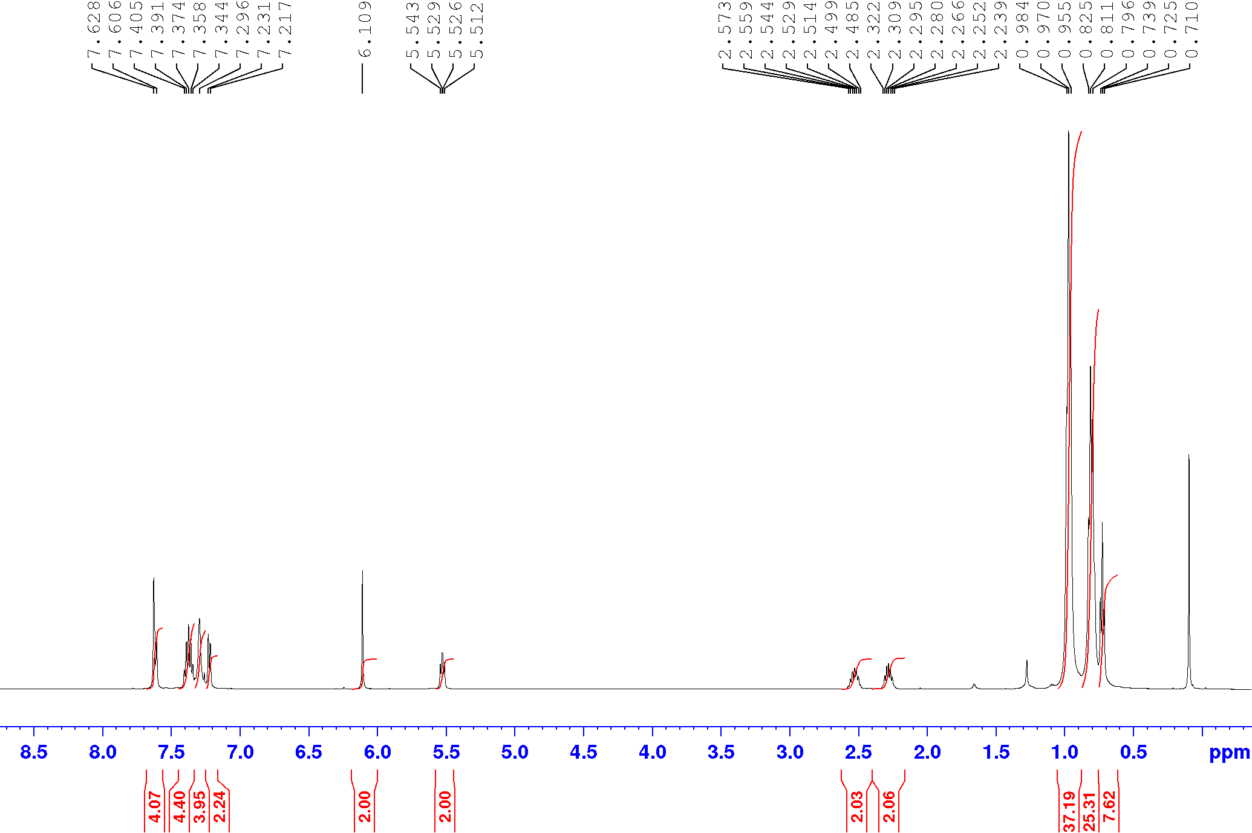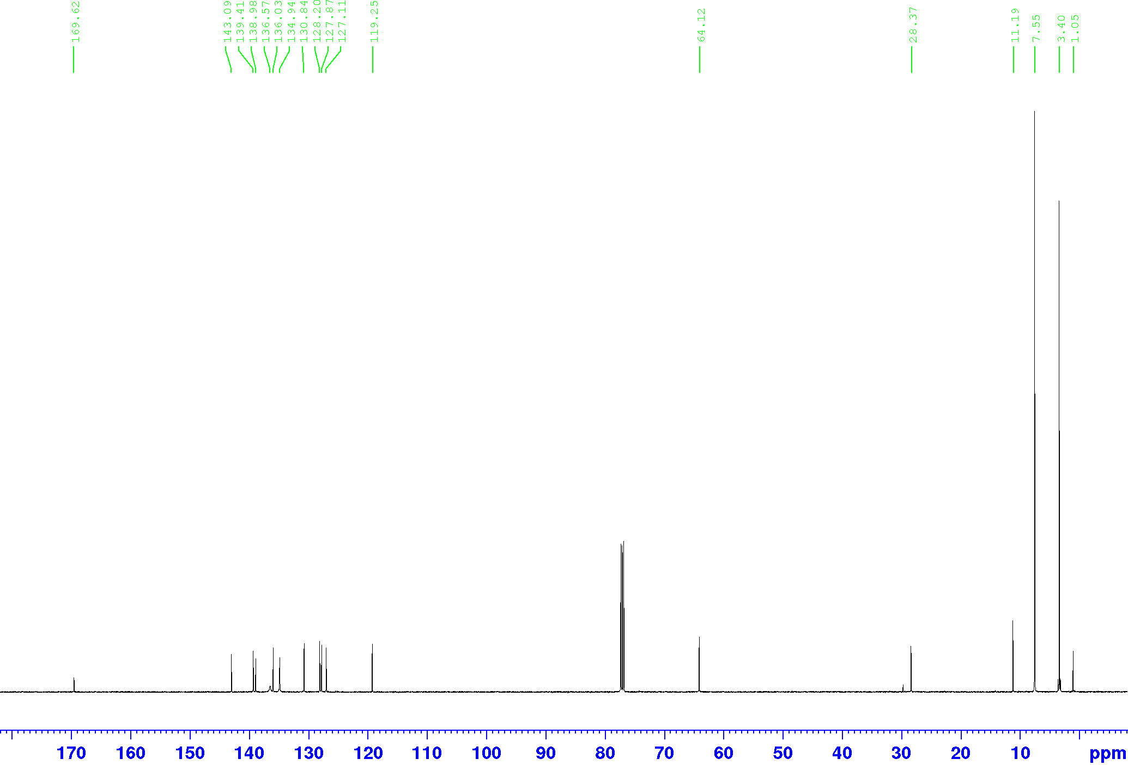



**Figure 5.** Top: 1H NMR of the gold complex **18b**; bottom: 13C NMR of the gold complex **18b.**

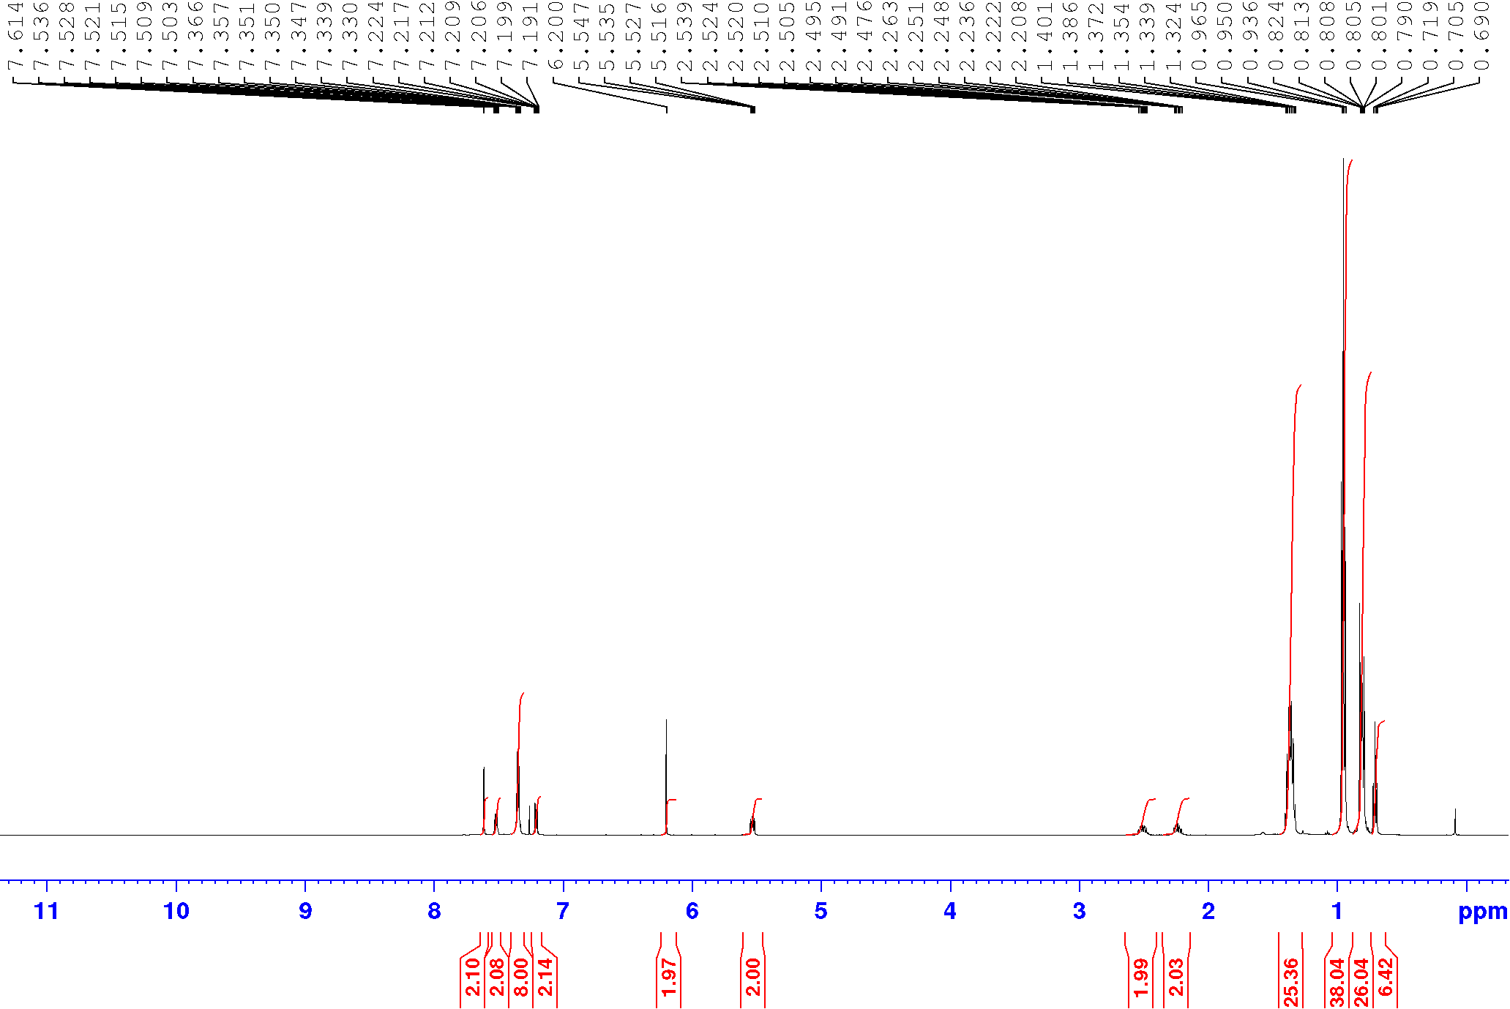



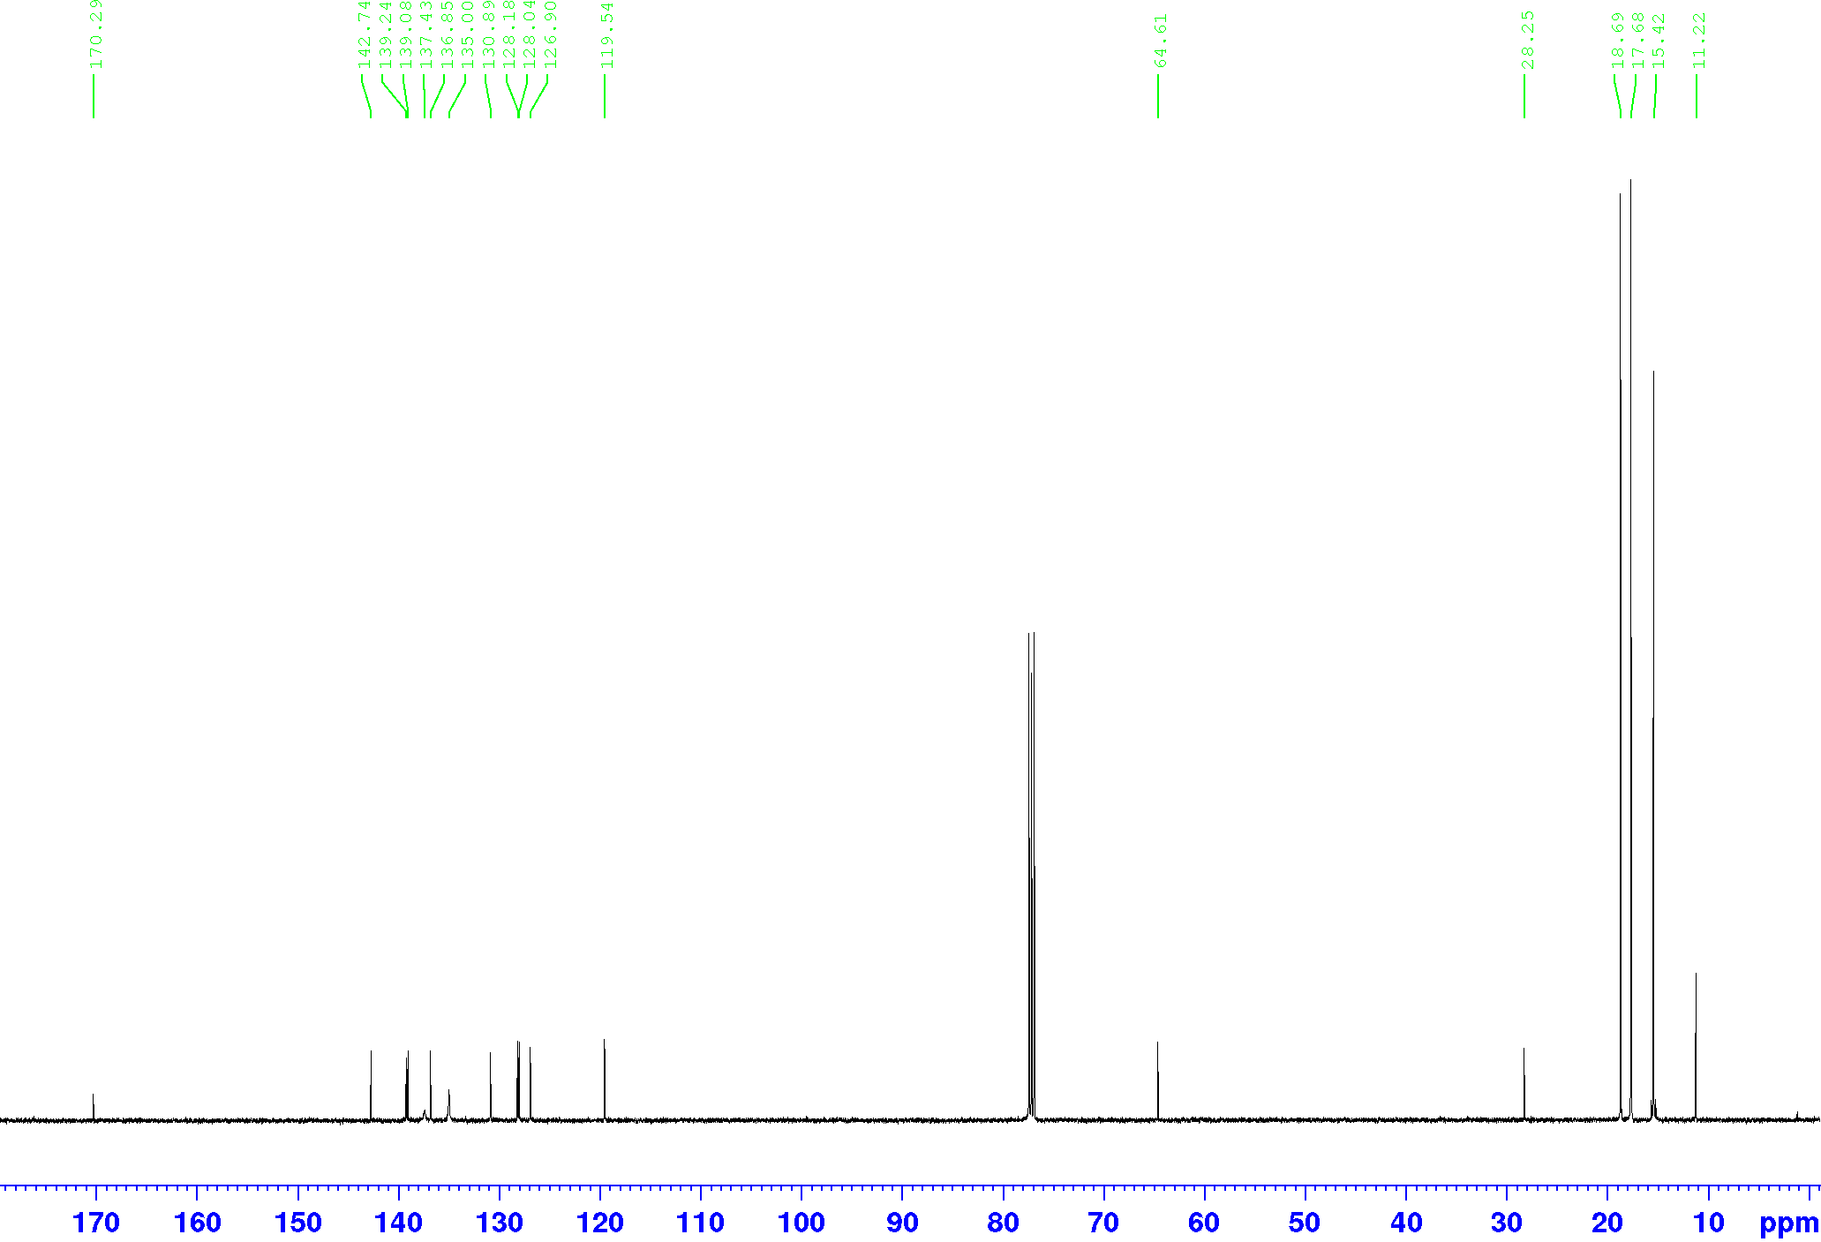



**Figure 6.** Top: 1H NMR of the gold complex **18c**; bottom: 13C NMR of the gold complex **18c.**

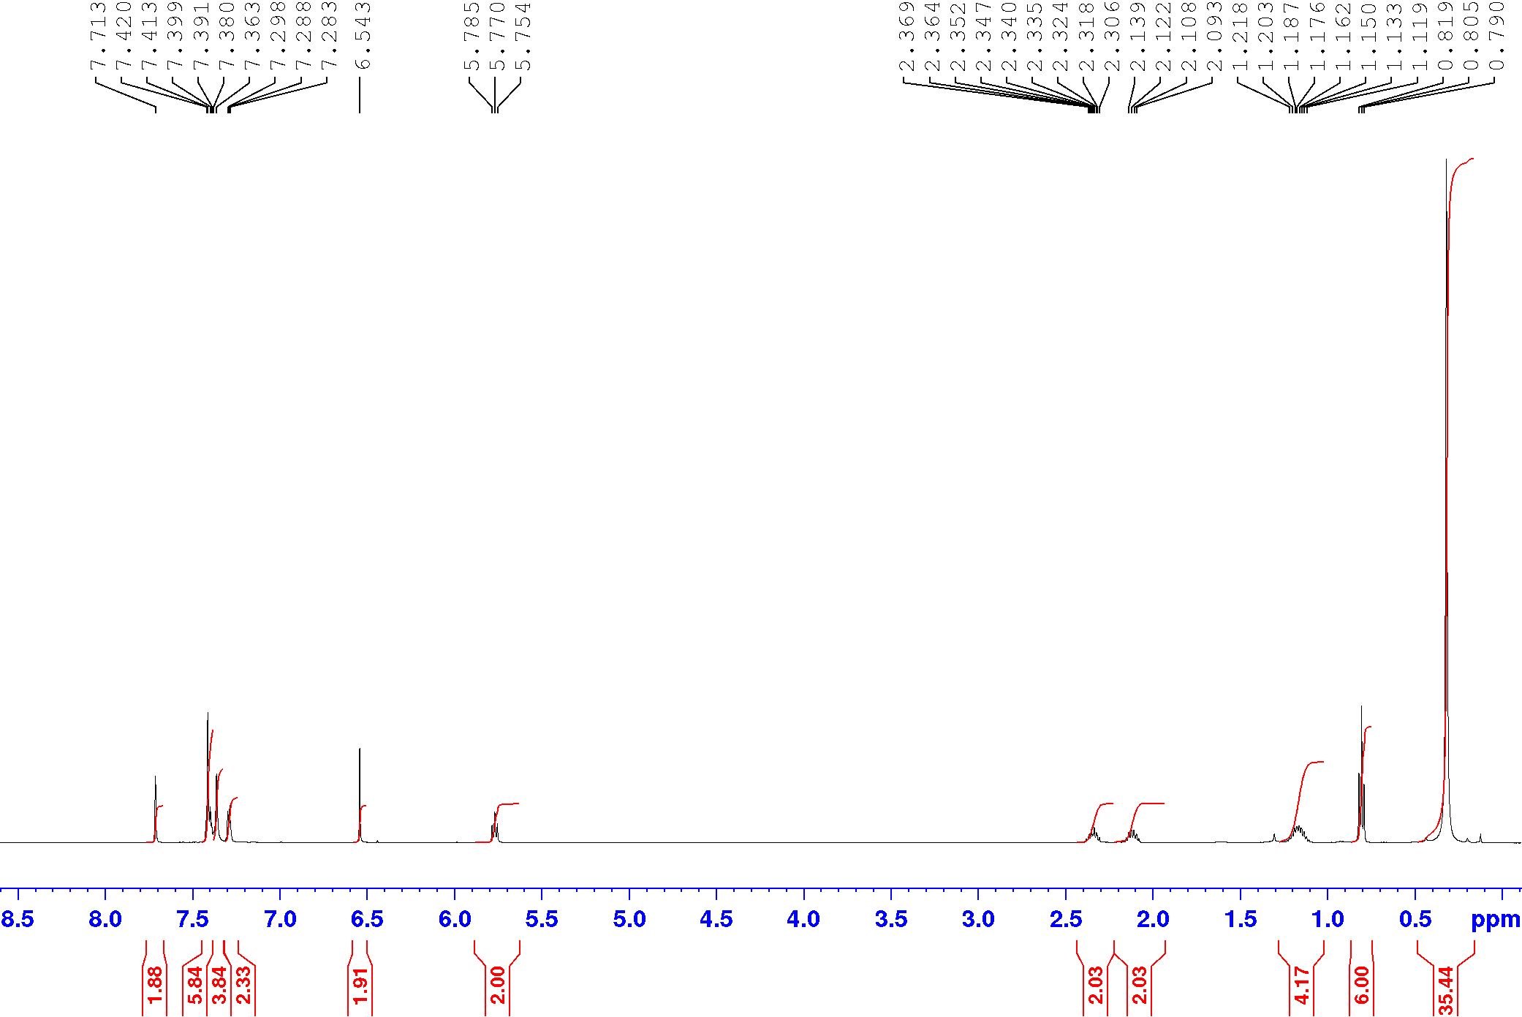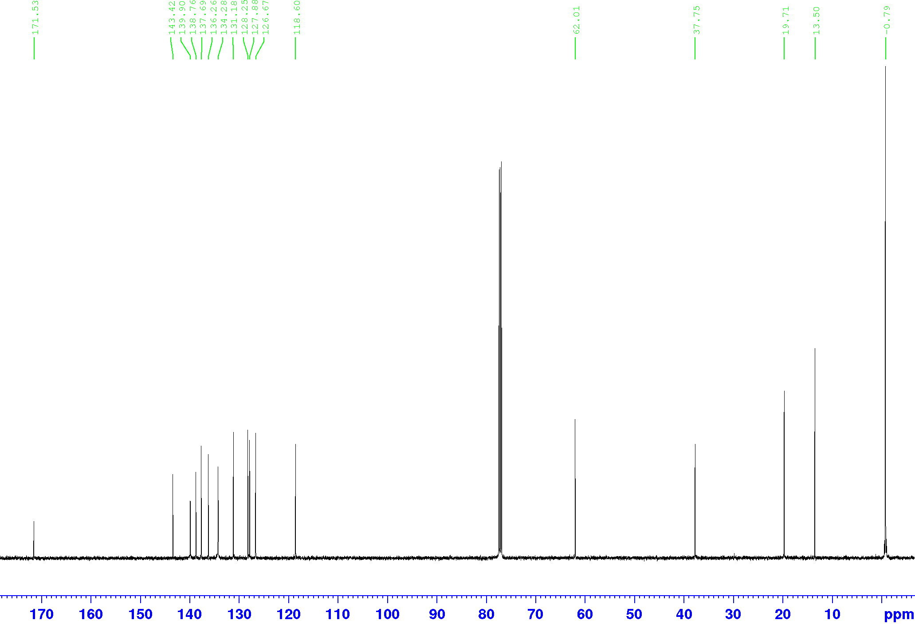



**Figure 7.** Top: 1H NMR of the gold complex **19a**; bottom: 13C NMR of the gold complex **19a.**

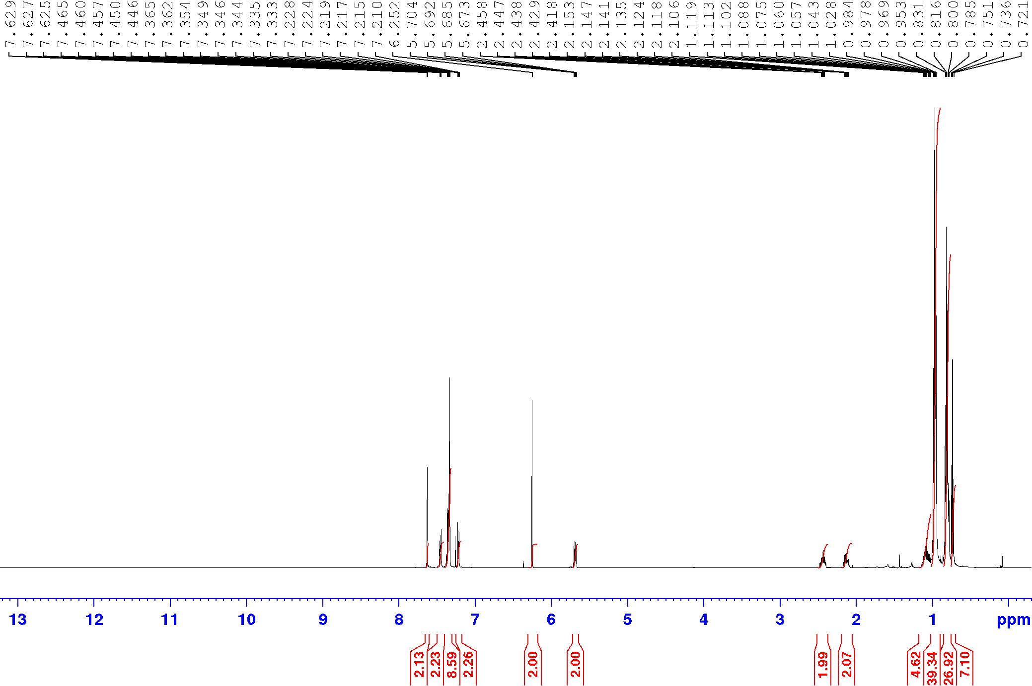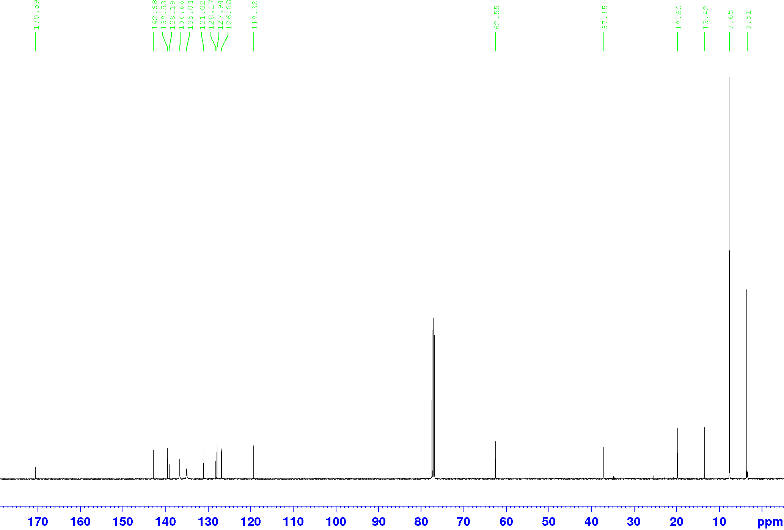



**Figure 8.** Top: 1H NMR of the gold complex **19b**; bottom: 13C NMR of the gold complex **19b.**

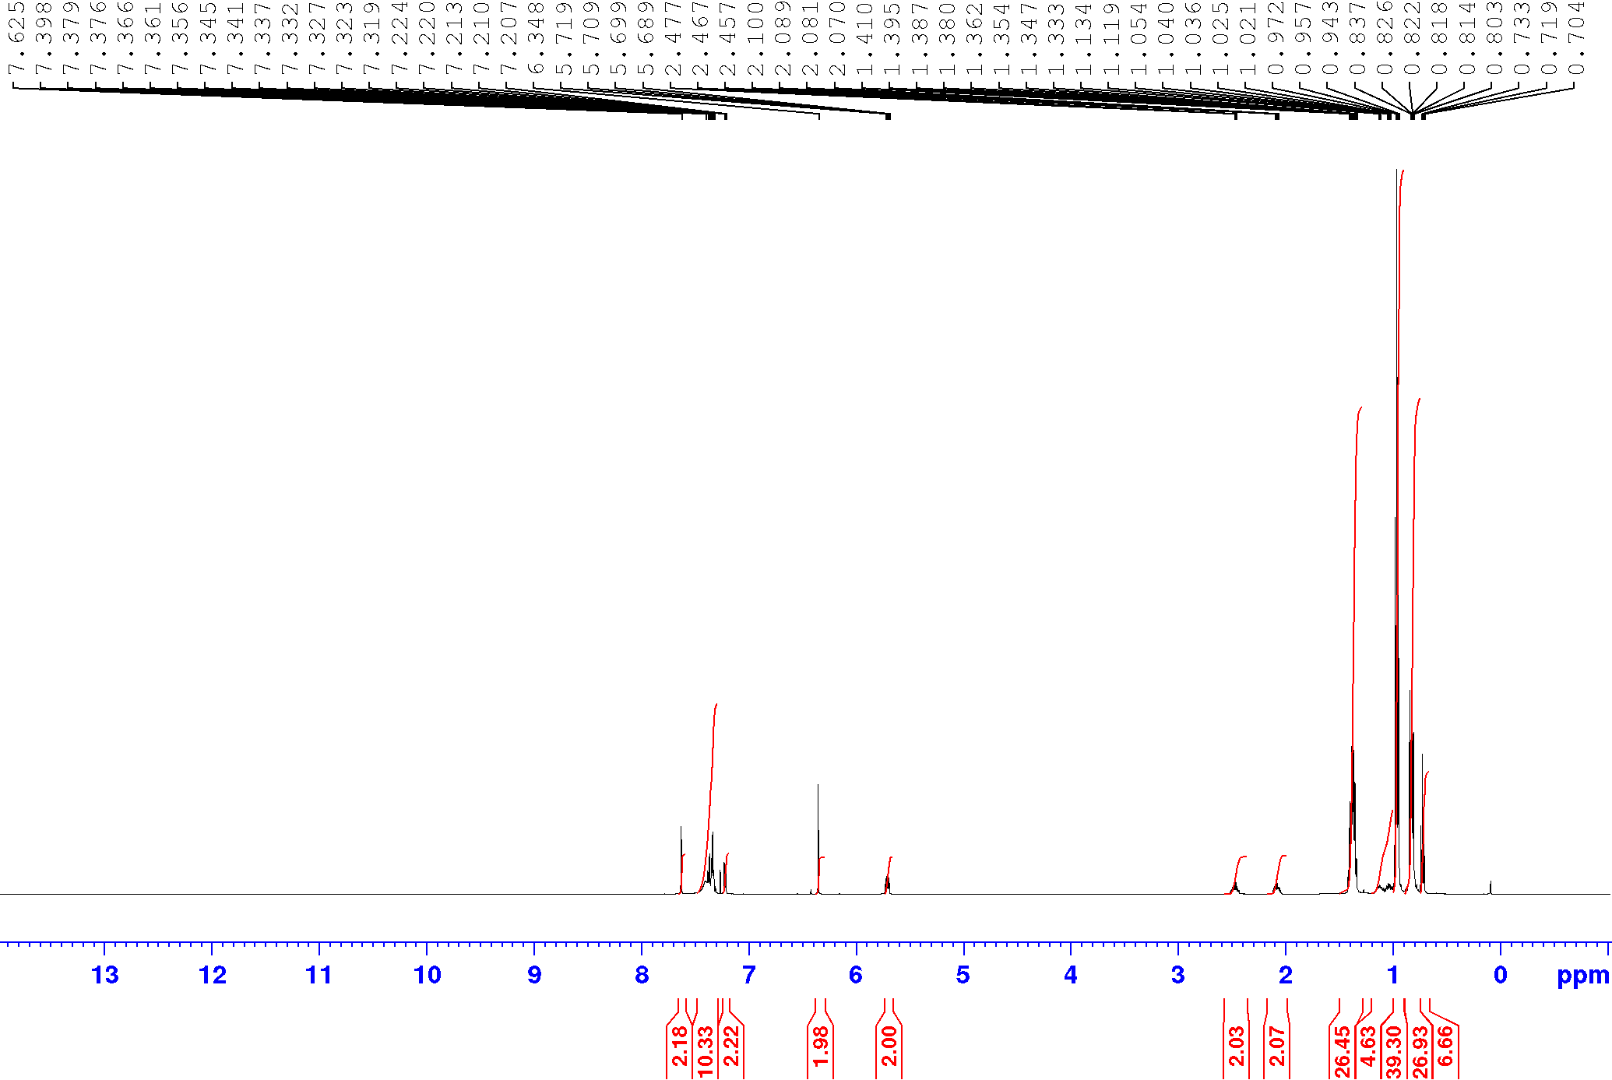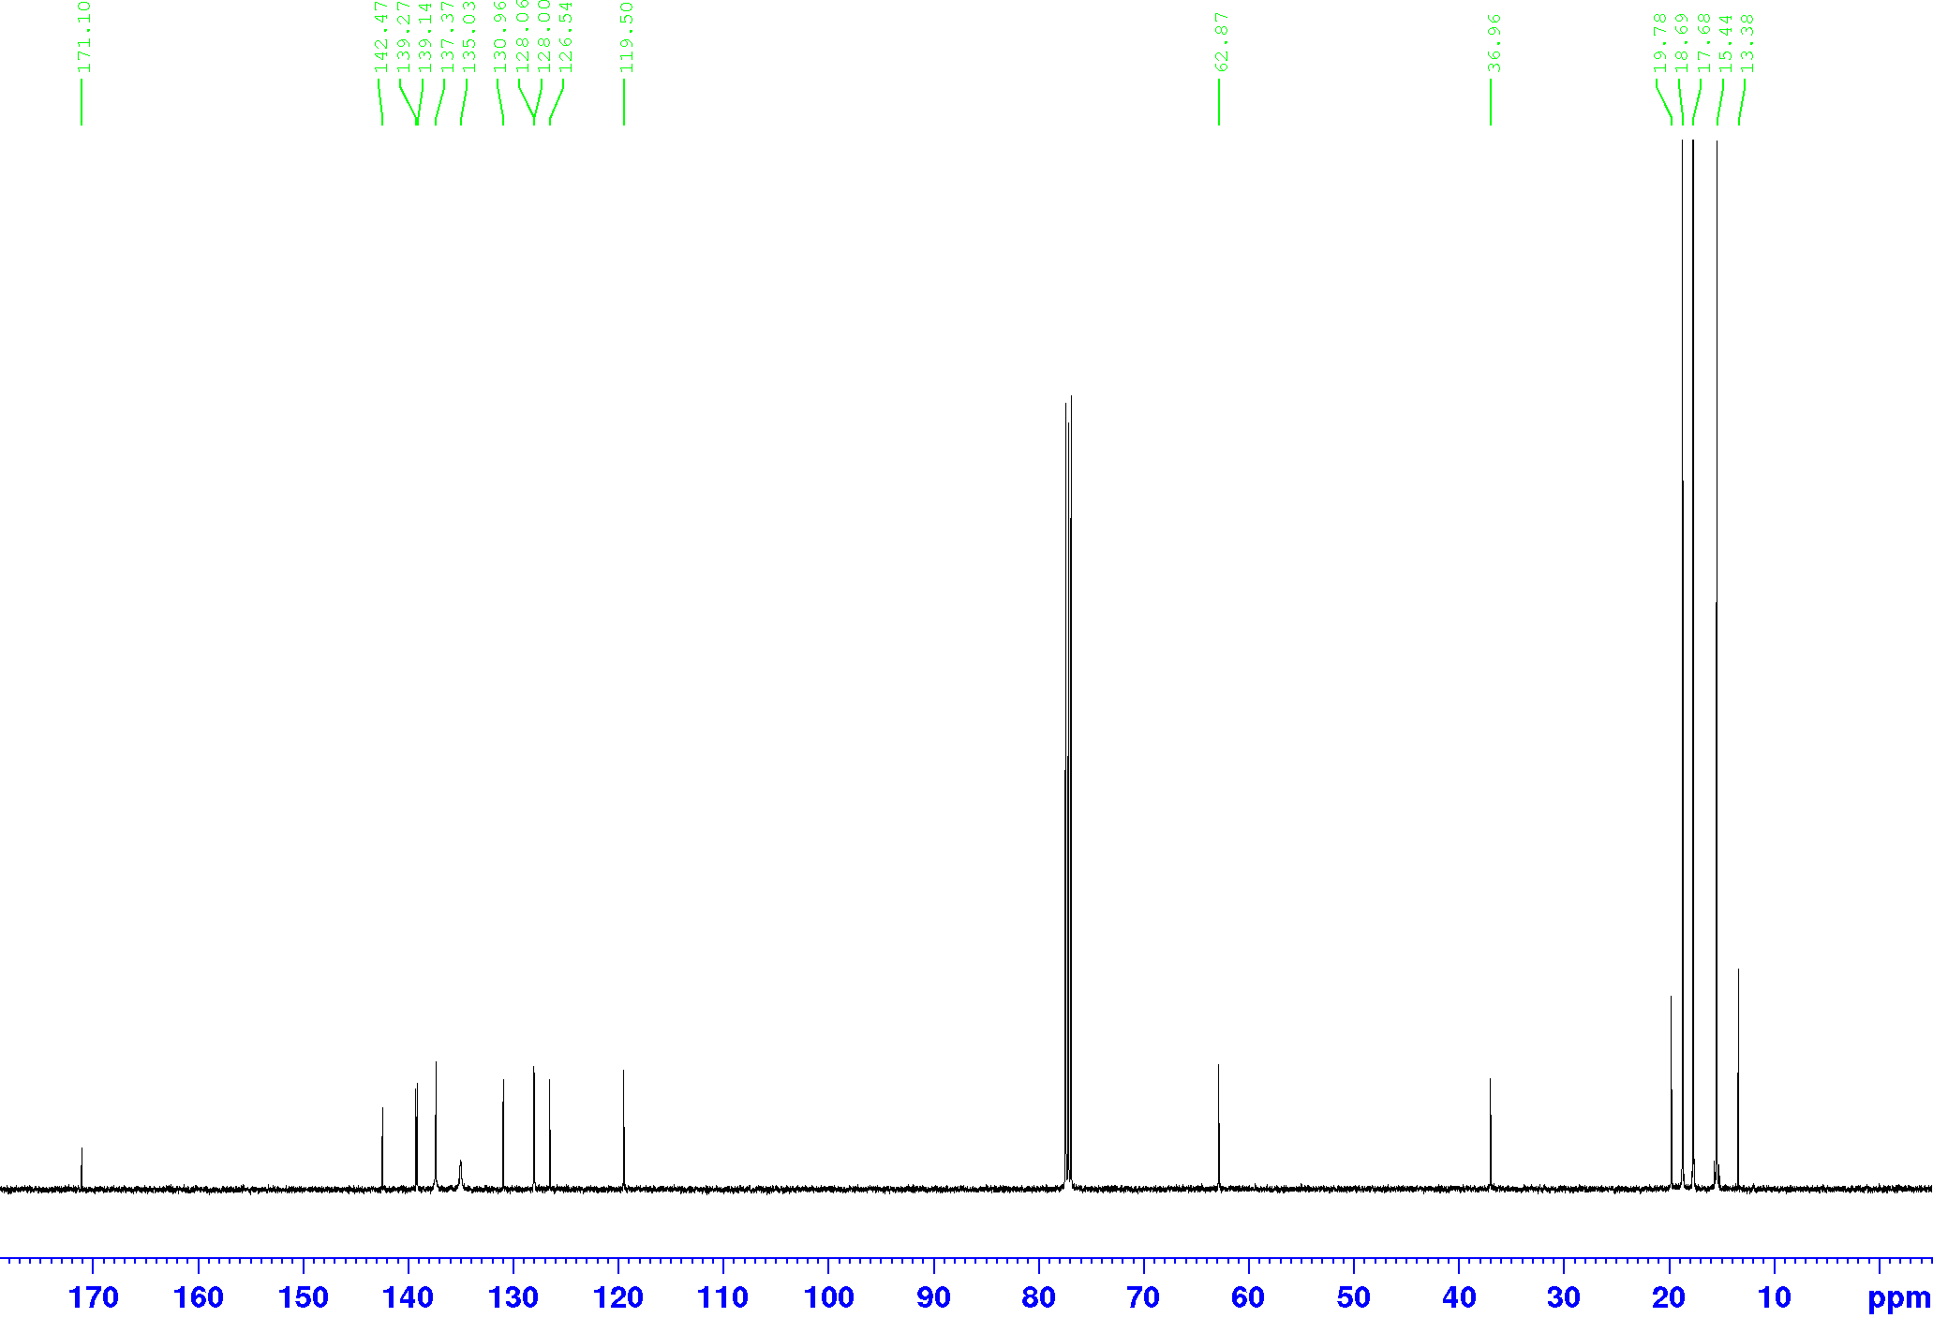



**Figure 9.** Top: 1H NMR of the gold complex **19c**; bottom: 13C NMR of the gold complex **19c.**

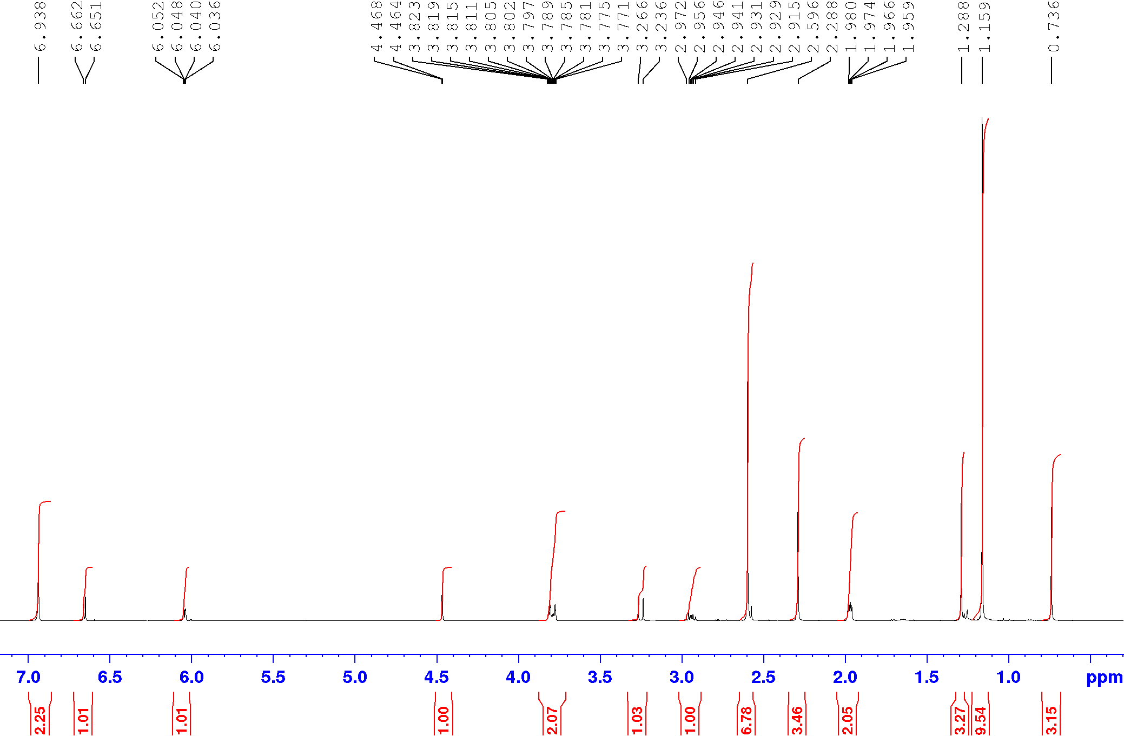



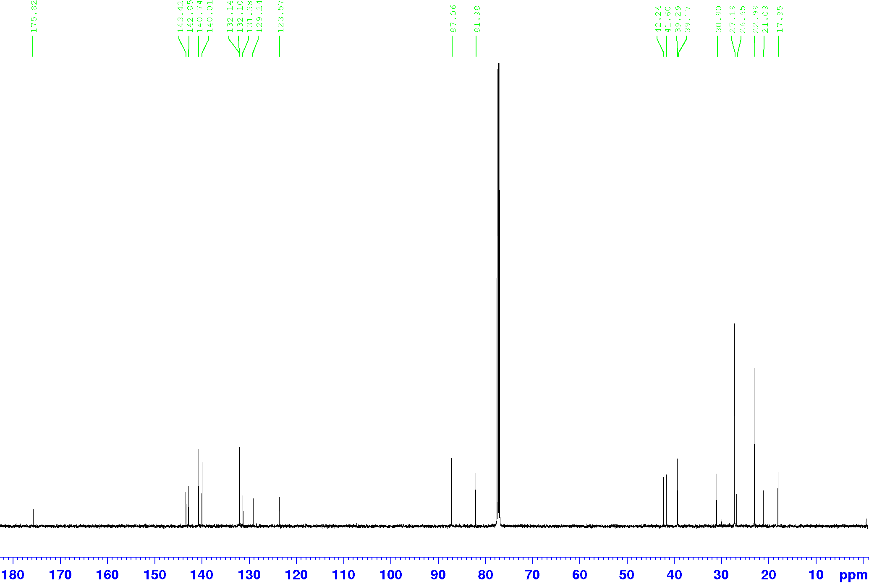



**Figure 10.** Top: 1H NMR of the cycloaddition product **24**; bottom: 13C NMR of the cycloaddition product **24.**

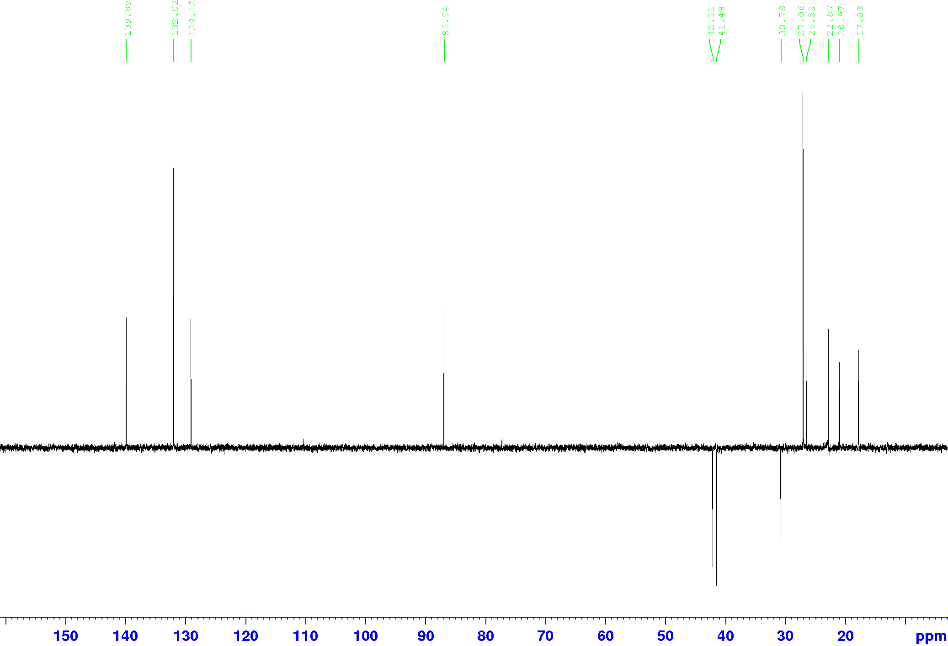



**Figure 11.** DEPT-135 spectrum of the cycloaddition product **24.**





**Figure 12.** COZY spectrum of the cycloaddition product **24.**





**Figure 13.** HSQC spectrum of the cycloaddition product **24.**

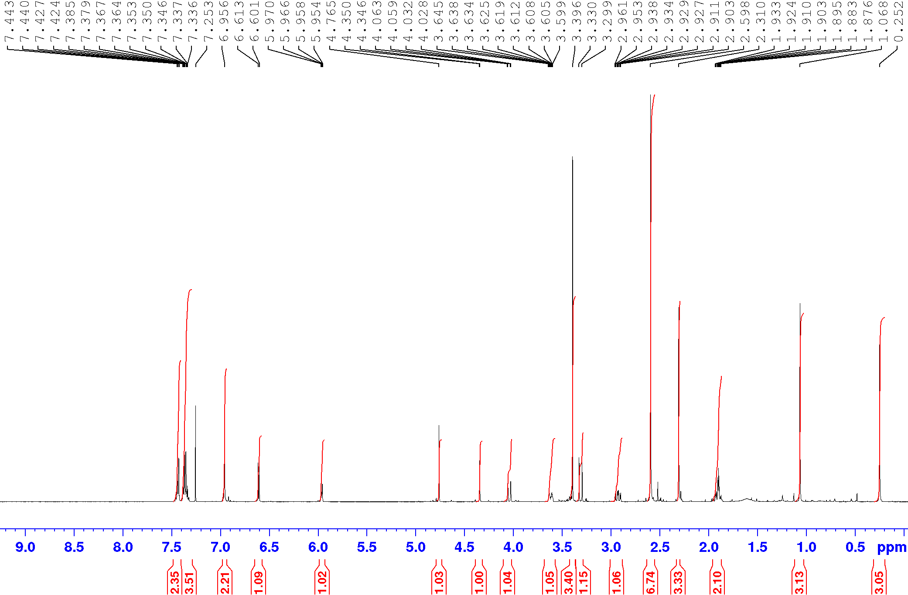



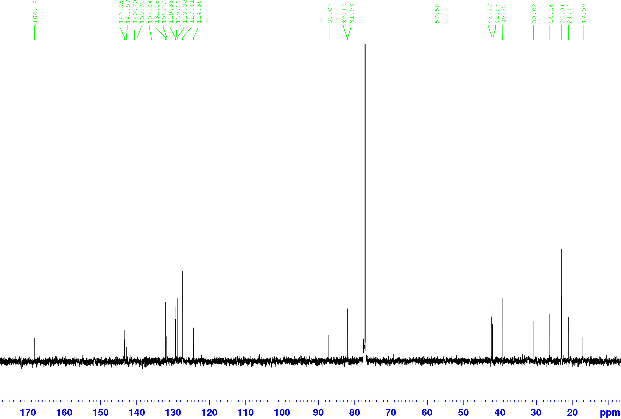



**Figure 14.** Top: 1H NMR of the cycloaddition product **29**; bottom: 13C NMR of the cycloaddition product **29.**

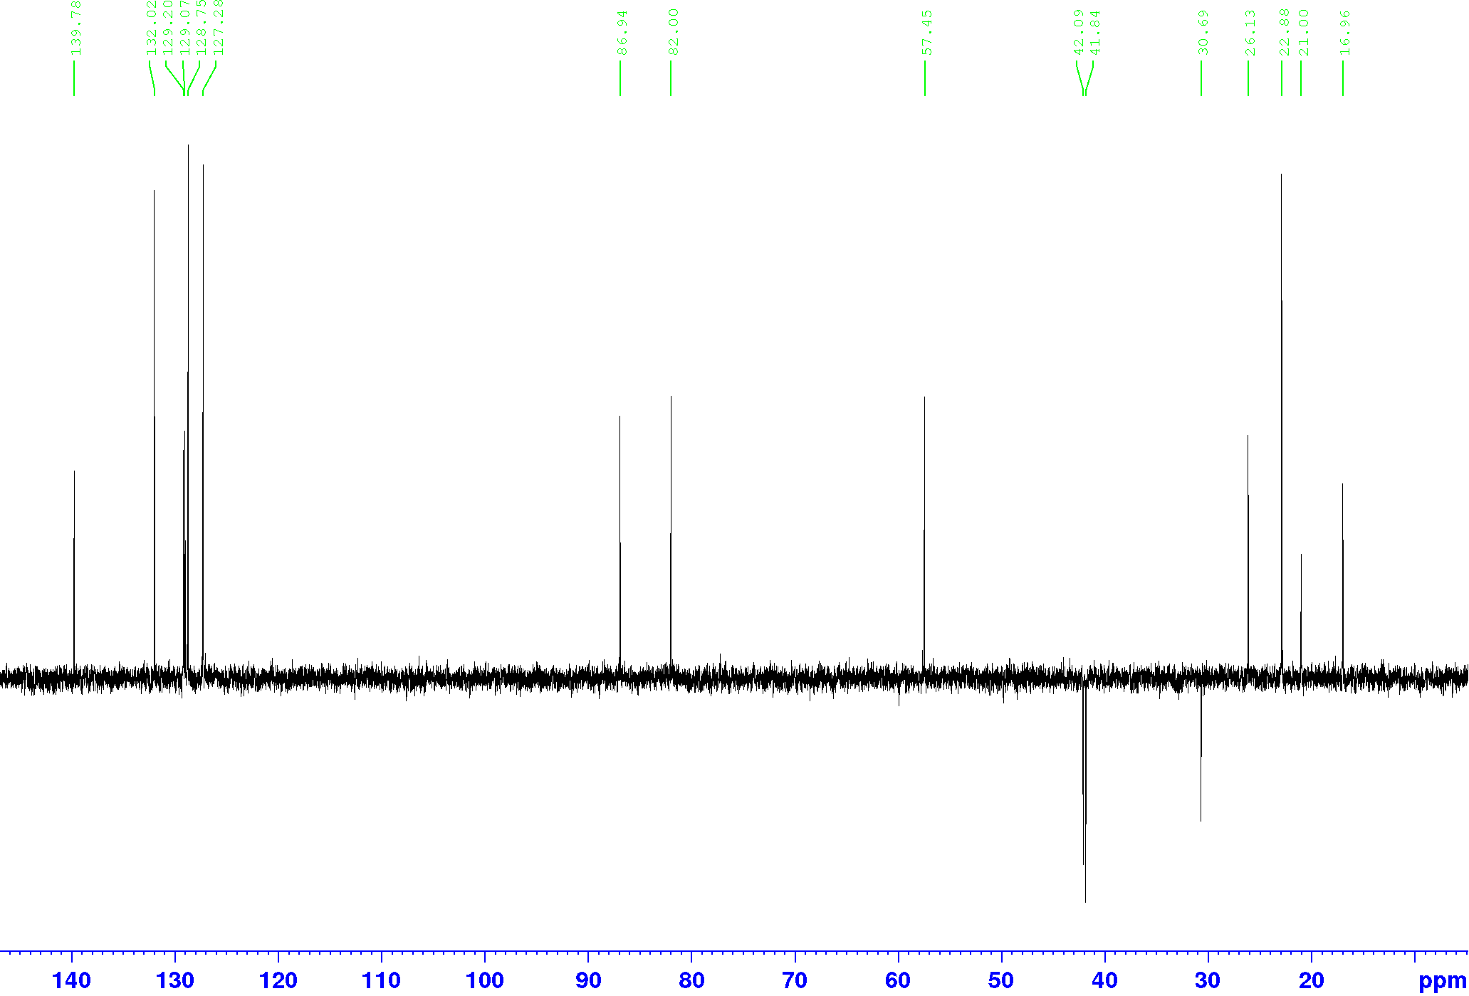



**Figure 15.** DEPT-135 spectrum of the cycloaddition product **29.**

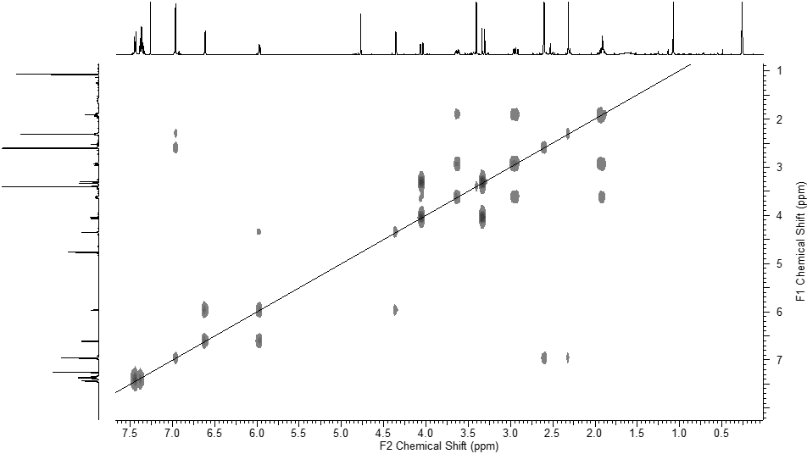



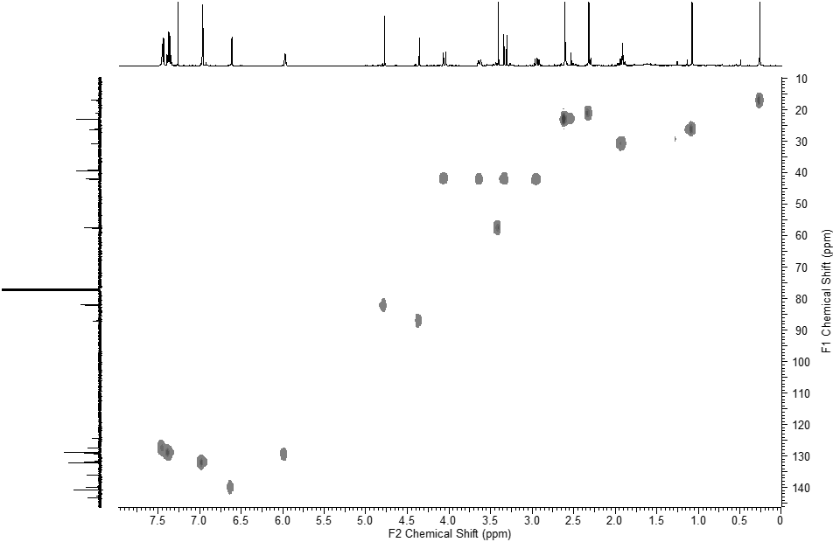



**Figure 16.** Top: COZY spectrum of the cycloaddition product **29**; bottom: HSQC spectrum of the cycloaddition product **29.**